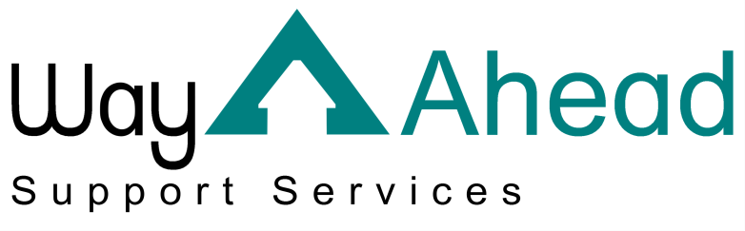
…Award winning service offering support the way you want it.

This is Way Ahead Support Services Privacy Notice.
As part of the services we offer, we are required to process personal data about our staff, the Individuals we support and, in some instances, the friends or relatives of our service users and staff. “Processing” can mean collecting, recording, organising, storing, sharing or destroying data.
We are committed to being transparent about why we need your personal data and what we do with it. This information is set out in this privacy notice. It also explains your rights when it comes to your data.
If you have any concerns or questions please contact us via: email: info@wayaheaduk.org telephone: 01926 622980 or post: Way Ahead Support Services, 4 Jephson Court, Tancred Close, Leamington Spa, Warwickshire, CV31 3RZ.

Individuals we support.

What data do we have?
So that we can provide a safe and professional service, we need to keep certain records about you. We may process the following types of data:
- Your basic details and contact information e.g. your name, address, date of birth and next of kin;
- Your financial details e.g. details of how you pay us for your care or your funding arrangements.
We also record the following data which is classified as “special category”:
- Health and social care data about you, which might include both your physical and mental health data.
- We may also record data about your race, ethnic origin, sexual orientation or religion.

Why do we have this data?
We need this data so that we can provide high-quality care and support. By law, we need to have a lawful basis for processing your personal data.
We process your data because:
- We have a legal obligation to do so – generally under the Health and Social Care Act 2012 or Mental Capacity Act 2005.
We process your special category data because
- It is necessary due to social security and social protection law (generally this would be in safeguarding instances);
- It is necessary for us to provide and manage social care services;
- We are required to provide data to our regulator, the Care Quality Commission (CQC), as part of our public interest obligations.

We may also process your data with your consent. If we need to ask for your permission, we will offer you a clear choice and ask that you confirm to us that you consent. We will also explain clearly to you what we need the data for and how you can withdraw your consent at any time.

Where do we process your data?
So that we can provide you with high quality care and support we need specific data. This is collected from or shared with:
- You or your legal representative(s);
- Third parties.
We may do this face to face, via phone, via email, via our website, via post, via application forms or via apps.
Third parties are organisations we might lawfully share your data with include:
- Other parts of the health and care system such as local hospitals, the GP, the pharmacy, social workers, clinical commissioning groups, and other health and care professionals;
- The Local Authority;
- Your family or friends – with your permission;
- Organisations we have a legal obligation to share information with i.e. for safeguarding, the CQC;
- The police or other law enforcement agencies, if we have to by law or court order.

Your rights
The data that we keep about you is your data and we ensure that we keep it confidential and that it is used appropriately. You have the following rights when it comes to your data:
- You have the right to request a copy of all of the data we keep about you. Generally, we will not charge for this service;
- You have the right to ask us to correct any data we have which you believe to be inaccurate or incomplete. You can also request that we restrict all processing of your data while we consider your rectification request;
- You have the right to ask that we erase any of your personal data which is no longer necessary for the purpose we originally collected it for. We retain our data in line with the Information Governance Alliance’s guidelines (https://digital.nhs.uk/data-and-information/looking-after-information/data-security-and-information-governance/codes-of-practice-for-handling-information-in-health-and-care/records-management-code-of-practice-for-health-and-social-care-2016)
- You may also request that we restrict processing if we no longer require your personal data for the purpose we originally collected it for, but you do not wish for it to be erased.
- You can ask for your data to be erased if we have asked for your consent to process your data. You can withdraw consent at any time – please contact us to do so.
- If we are processing your data as part of our legitimate interests as an organisation or in order to complete a task in the public interest, you have the right to object to that processing. We will restrict all processing of this data while we look into your objection.
You may need to provide adequate information for our staff to be able to identify you, for example, a passport or driver’s licence. This is to make sure that data is not shared with the wrong person inappropriately. We will always respond to your request as soon as possible and at the latest within one month.
If you would like to complain about how we have dealt with your request, please contact:
Information Commissioner’s Office
Wycliffe House
Water Lane
Wilmslow
Cheshire
SK9 5AF
https://ico.org.uk/global/contact-us/

