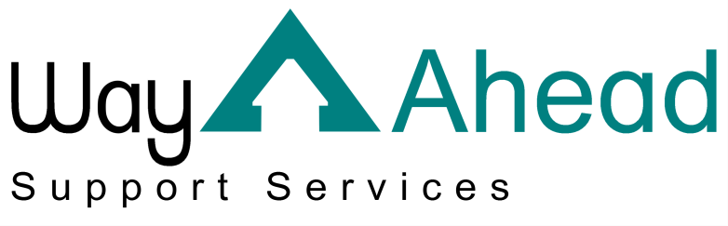
…Award winning service offering support the way you want it.

This is Way Ahead Support Services’ Privacy Notice.
As part of the services we offer, we are required to process personal data about our staff, our service users and, in some instances, the friends or relatives of our service users and staff. “Processing” can mean collecting, recording, organising, storing, sharing or destroying data.
We are committed to being transparent about why we need your personal data and what we do with it. This information is set out in this privacy notice. It also explains your rights when it comes to your data.
If you have any concerns or questions please contact us: If you have any concerns or questions please contact us via: email: info@wayaheaduk.org telephone: 01926 622980 or post: Way Ahead Support Services, 4 Jephson Court, Tancred Close, Leamington Spa, Warwickshire, CV31 3RZ.

Friends/Relatives

What data do we have?
As part of our work providing high-quality care and support, it might be necessary that we hold the following information on you:
- Your basic details and contact information e.g. your name and address.

Why do we have this data?
By law, we need to have a lawful basis for processing your personal data.
We process your data because we have a legitimate business interest in holding next of kin and lasting power of attorney information about the individuals who use our service and keeping emergency contact details for our staff.
We may also process your data with your consent. If we need to ask for your permission, we will offer you a clear choice and ask that you confirm to us that you consent. We will also explain clearly to you what we need the data for and how you can withdraw your consent.

Where do we process your data?
So that we can provide high quality care and support we need specific data. This is collected from or shared with:
- You or your legal representative(s);
- Third parties.
We may do this face to face, via phone, via email, via our website, via post, via application forms or via apps.
Third parties are organisations we have a legal reason to share your data with. These may include:
- Other parts of the health and care system such as local hospitals, the GP, the pharmacy, social workers, and other health and care professionals;
- The Local Authority;
- The police or other law enforcement agencies if we have to by law or court order.

Your rights
The data that we keep about you is your data and we ensure that we keep it confidential and that it is used appropriately. You have the following rights when it comes to your data:
- You have the right to request a copy of all of the data we keep about you. Generally, we will not charge for this service;
- You have the right to ask us to correct any data we have which you believe to be inaccurate or incomplete. You can also request that we restrict all processing of your data while we consider your rectification request;
- You have the right to ask that we erase any of your personal data which is no longer necessary for the purpose we originally collected it for. We retain our data in line with the Information Governance Alliance’s guidelines (https://digital.nhs.uk/data-and-information/looking-after-information/data-security-and-information-governance/codes-of-practice-for-handling-information-in-health-and-care/records-management-code-of-practice-for-health-and-social-care-2016)
- You may also request that we restrict processing if we no longer require your personal data for the purpose we originally collected it for, but you do not wish for it to be erased.
- You can ask for your data to be erased if we have asked for your consent to process your data. You can withdraw consent at any time – please contact us to do so.
- If we are processing your data as part of our legitimate interests as an organisation or in order to complete a task in the public interest, you have the right to object to that processing. We will restrict all processing of this data while we look into your objection.
You may need to provide adequate information for our staff to be able to identify you, for example, a passport or driver’s licence. This is to make sure that data is not shared with the wrong person inappropriately. We will always respond to your request as soon as possible and at the latest within one month.
If you would like to complain about how we have dealt with your request, please contact:
Information Commissioner’s Office
Wycliffe House
Water Lane
Wilmslow
Cheshire
SK9 5AF
https://ico.org.uk/global/contact-us/

